cbm::

**ensemble faire plus**

September 8th, 2021

Ref: **/AB/CBM

*Construire une societe inclusive*

Bureau National de Coordination NIGER

Quartier Dar Es Salam, Avenue de la Radio YN 117

Pave Tegui

BP : 10731 Niamey - Niger

Tel. : +227 20 35 17 07

Cel. : +227 97 40 62 65

E-mail: [co-niger@cbm.org](mailto:co-niger@cbm.org)

Site internet: [www.cbm.org](http://www.cbm.org)

GAFSP Coordination Unit

**Objet:** Support for the proposal to GAFSP OP Niger

On behalf of CBM Christoffel-Blindenmission Christian Blind Mission e.V. (CBM) I am pleased to confirm that CBM supports the Project Proposal "Strengthening farmers’ organizations to develop sustainable livelihoods in Niger" under the GAFSP Funding Stream "Producer Organization Window 2021 - Special Call for Proposals" in Niger as co-financing entity.

We have worked closely with Mooriben Federation and the supervision entity FAO, in the proposal design through a series of consultations that involved farmer's organizations, government agencies, private sector and civil society. We are willing and ready to collaborate in the project in following components:

* Component 1: Organizational strengthening of the Unions and OPB members of the FUGPN Mooriben Federation in Dosso and Tillaberi Regions
* Component 2: Farmers' organizations (Unions and OPBs) develop resilient and adapted value chains to improve food and nutritional security in the intervention communes
* Component 3: Coordination, monitoring and capitalization of the project through co-financing related activities in accordance with the financing plan of the project with an amount of apx. 75 000 Euros per year, through designated funding.

We hope on a favourable outcome and stand ready to provide further support during the

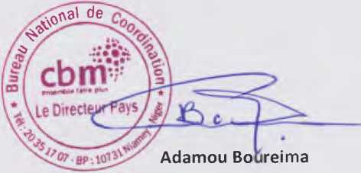detailed project design and implementation.

Country Director

Yours sincerely,

Bureau National de Coordination du Niger est une antenne locale du Bureau Regional de CBM pour TAfrique de I'Ouest

Rue des Mercuriales Residence du Benin - BP. 13489 LomO, Togo - T6L +228 226 32 20 / +228 226 02 37